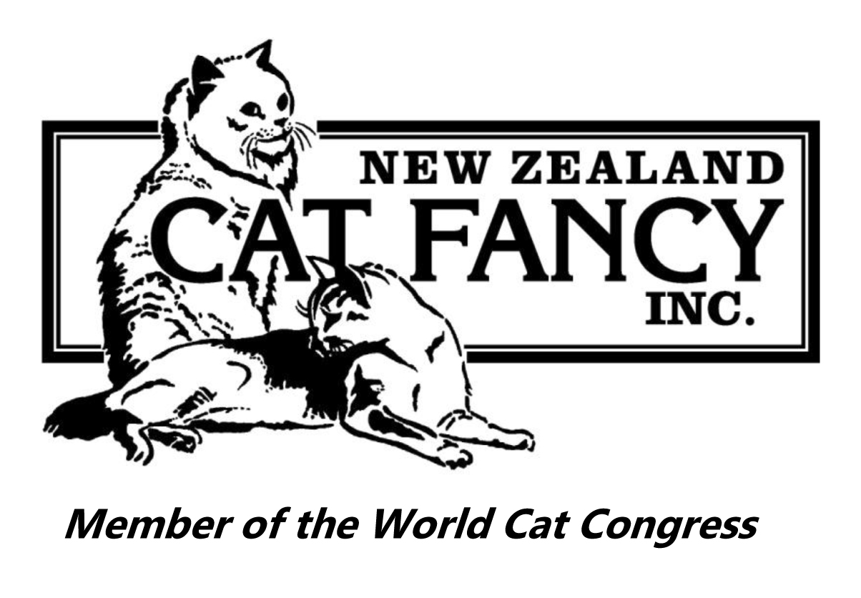
NEW ZEALAND CAT FANCY INC.

Top Ten Results
Show: Longhair Cat Breeders Association (Inc) Date: 16 May 2021
Longhair Division
Ring No.
1
Judge: Annette Dunn
Entire Cats
Number of Cats in Ring: 11
Place | Cage No. | Pedigree Name | Breed
BIS | 108 | ISHCUS KILLIAN | Maine Coon
2nd | 111 | ANGELSNOUTLAWS ATHENA | Norwegian Forest Cat
3rd | 105 | SINHIMAN QUEEN OF THE VALKYRIE | Birman
4th | 101 | MINOSA KINKY BOOTS | Birman
5th | 106 | YEUXDESAPHIR FOREVA PURPLE REIGN | Birman
6th | 102 | SPELLBOUND CURRAGHMORE | Birman
7th | 104 | LEEGRGO LOVING MOMENTS | Birman
8th | 107 | AURORAPETZ SCARLETT-AMY-M | Ragdoll
9th | 110 | ANGELSNOUTLAWS ANTOINETTE | Norwegian Forest Cat
10th | 103 | SPELLBOUND L AMOR BOSTON | Birman
BAM | 108 | ISHCUS KILLIAN | Maine Coon

Entire Kittens
Number of Kittens in Ring: 14
Place | Cage No. | Pedigree Name | Breed
BIS | 210 | RAGALON BIG DREAMS | Ragdoll
2nd | 206 | SINHIMAN QING OF VALHALLA | Birman
3rd | 214 | KITTYCOURT COCONUT ICE | Maine Coon
4th | 211 | RAGALON LITTLE ANGEL | Ragdoll
5th | 207 | MOONSON SUGAR PLUM FAIRY | Birman
6th | 205 | MOONSON BENJAMIN BEAR | Birman
7th | 203 | ISPISAKAT MOONLIGHT KISSES | Exotic
8th | 213 | MAINELANDERS SIR RAFFERTY | Maine Coon
9th | 212 | MAINELANDERS SAINT PADRAIG | Maine Coon
10th | 209 | STARPAWS IRASCIBILTY | Birman
BAM | 210 | RAGALON BIG DREAMS | Ragdoll

Neuter/Spay Cats
Number of Cats in Ring: 15
Place | Cage No. | Pedigree Name | Breed
BIS | 302 | MAGICBOX CHANTILLY LACE | Persian
2nd | 315 | KIWIMAGIC TALES OF ARCHIE | Ragdoll
3rd | 304 | TANIVER LUCKY CHANCE | Persian
4th | 303 | ISPISAKAT FIREWORKS | Persian
5th | 310 | BELZICATZ LORD BARNABY | Birman
6th | 311 | SINHIMAN DREAM ILLUSION | Birman
7th | 305 | TANIVER A SPECIAL KIND OF MAGIC | Persian
8th | 312 | FLORENCIA MISS SAPHIRE | Birman
9th | 301 | PEPPERBOX MYTEE KNIGHT | Persian
10th | 309 | BELZICATZ LORD RICHMOND | Birman
BAM | 315 | KIWIMAGIC TALES OF ARCHIE | Ragdoll

Neuter/Spay Kittens
Number of Kittens in Ring: 5
Place | Cage No. | Pedigree Name | Breed
BIS | 404 | CADIKEDISI NESELI NUR | Turkish Angora
2nd | 403 | SHININGWATER HAN SOLO | Maine Coon
3rd | 405 | CADIKEDISI NEFES NEFESE KALMAK | Turkish Angora
4th | 401 | TANIVER CREME BEAR | Persian
5th | 402 | VLADIMIR TAME ITI | Maine Coon
BAM | 404 | CADIKEDISI NESELI NUR | Turkish Angora
Companion Division
Longhair Companions
Number of LH Companions in Ring: 4
Place | Cage No. | Name
BIS | 951 | WHYNOT
2nd | 954 | SQUEAK
3rd | 952 | RED RASCAL
4th | 953 | EREBUS
Domestic Division
Shorthair Domestics
Number of SH Domestics in Ring: 1
Place | Cage No. | Name
BIS | 901 | BARRY

Longhair Division
Ring No.
2
Judge: Sharon Jose
Entire Cats
Number of Cats in Ring: 11
Place | Cage No. | Pedigree Name | Breed
BIS | 101 | MINOSA KINKY BOOTS | Birman
2nd | 108 | ISHCUS KILLIAN | Maine Coon
3rd | 102 | SPELLBOUND CURRAGHMORE | Birman
4th | 105 | SINHIMAN QUEEN OF THE VALKYRIE | Birman
5th | 106 | YEUXDESAPHIR FOREVA PURPLE REIGN | Birman
6th | 109 | MAINELANDERS CHECKERS PP | Maine Coon
7th | 110 | ANGELSNOUTLAWS ANTOINETTE | Norwegian Forest Cat
8th | 111 | ANGELSNOUTLAWS ATHENA | Norwegian Forest Cat
9th | 104 | LEEGRGO LOVING MOMENTS | Birman
10th | 103 | SPELLBOUND L AMOR BOSTON | Birman
BAM | 102 | SPELLBOUND CURRAGHMORE | Birman

Entire Kittens
Number of Kittens in Ring: 14
Place | Cage No. | Pedigree Name | Breed
BIS | 212 | MAINELANDERS SAINT PADRAIG | Maine Coon
2nd | 205 | MOONSON BENJAMIN BEAR | Birman
3rd | 210 | RAGALON BIG DREAMS | Ragdoll
4th | 213 | MAINELANDERS SIR RAFFERTY | Maine Coon
5th | 211 | RAGALON LITTLE ANGEL | Ragdoll
6th | 214 | KITTYCOURT COCONUT ICE | Maine Coon
7th | 206 | SINHIMAN QING OF VALHALLA | Birman
8th | 202 | ISPISAKAT FAIRY TALE | Persian
9th | 208 | SINHIMAN QUEEN OF HVERGELMIR | Birman
10th | 204 | ISPISAKAT SILVER MOON | Exotic
BAM | 210 | RAGALON BIG DREAMS | Ragdoll

Neuter/Spay Cats
Number of Cats in Ring: 15
Place | Cage No. | Pedigree Name | Breed
BIS | 310 | BELZICATZ LORD BARNABY | Birman
2nd | 312 | FLORENCIA MISS SAPHIRE | Birman
3rd | 303 | ISPISAKAT FIREWORKS | Persian
4th | 302 | MAGICBOX CHANTILLY LACE | Persian
5th | 315 | KIWIMAGIC TALES OF ARCHIE | Ragdoll
6th | 311 | SINHIMAN DREAM ILLUSION | Birman
7th | 314 | TOLAYTUS WINTER SNOWSTORM | Birman
8th | 301 | PEPPERBOX MYTEE KNIGHT | Persian
9th | 309 | BELZICATZ LORD RICHMOND | Birman
10th | 306 | ISPISAKAT WILD CHILD | Exotic
BAM | 310 | BELZICATZ LORD BARNABY | Birman

Neuter/Spay Kittens
Number of Kittens in Ring: 5
Place | Cage No. | Pedigree Name | Breed
BIS | 403 | SHININGWATER HAN SOLO | Maine Coon
2nd | 404 | CADIKEDISI NESELI NUR | Turkish Angora
3rd | 401 | TANIVER CREME BEAR | Persian
4th | 405 | CADIKEDISI NEFES NEFESE KALMAK | Turkish Angora
5th | 402 | VLADIMIR TAME ITI | Maine Coon
BAM | 404 | CADIKEDISI NESELI NUR | Turkish Angora

Companion Division
Longhair Companions
Number of LH Companions in Ring: 4
Place | Cage No. | Name
BIS | 954 | SQUEAK
2nd | 951 | WHYNOT
3rd | 952 | RED RASCAL
4th | 953 | EREBUS
Domestic Division
Shorthair Domestics
Number of SH Domestics in Ring: 1
Place | Cage No. | Name
BIS | 901 | BARRY

Longhair Division
Ring No.
3
Judge: Michelle Magrath
Entire Cats
Number of Cats in Ring: 11
Place | Cage No. | Pedigree Name | Breed
BIS | 108 | ISHCUS KILLIAN | Maine Coon
2nd | 107 | AURORAPETZ SCARLETT-AMY-M | Ragdoll
3rd | 111 | ANGELSNOUTLAWS ATHENA | Norwegian Forest Cat
4th | 101 | MINOSA KINKY BOOTS | Birman
5th | 110 | ANGELSNOUTLAWS ANTOINETTE | Norwegian Forest Cat
6th | 109 | MAINELANDERS CHECKERS PP | Maine Coon
7th | 102 | SPELLBOUND CURRAGHMORE | Birman
8th | 104 | LEEGRGO LOVING MOMENTS | Birman
9th | 105 | SINHIMAN QUEEN OF THE VALKYRIE | Birman
10th | 106 | YEUXDESAPHIR FOREVA PURPLE REIGN | Birman
BAM | 108 | ISHCUS KILLIAN | Maine Coon

Entire Kittens
Number of Kittens in Ring: 14
Place | Cage No. | Pedigree Name | Breed
BIS | 211 | RAGALON LITTLE ANGEL | Ragdoll
2nd | 205 | MOONSON BENJAMIN BEAR | Birman
3rd | 202 | ISPISAKAT FAIRY TALE | Persian
4th | 212 | MAINELANDERS SAINT PADRAIG | Maine Coon
5th | 207 | MOONSON SUGAR PLUM FAIRY | Birman
6th | 214 | KITTYCOURT COCONUT ICE | Maine Coon
7th | 210 | RAGALON BIG DREAMS | Ragdoll
8th | 204 | ISPISAKAT SILVER MOON | Exotic
9th | 213 | MAINELANDERS SIR RAFFERTY | Maine Coon
10th | 203 | ISPISAKAT MOONLIGHT KISSES | Exotic
BAM | 211 | RAGALON LITTLE ANGEL | Ragdoll

Neuter/Spay Cats
Number of Cats in Ring: 15
Place | Cage No. | Pedigree Name | Breed
BIS | 305 | TANIVER A SPECIAL KIND OF MAGIC | Persian
2nd | 311 | SINHIMAN DREAM ILLUSION | Birman
3rd | 315 | KIWIMAGIC TALES OF ARCHIE | Ragdoll
4th | 301 | PEPPERBOX MYTEE KNIGHT | Persian
5th | 310 | BELZICATZ LORD BARNABY | Birman
6th | 302 | MAGICBOX CHANTILLY LACE | Persian
7th | 308 | BARBAROSSA MRS SASSY PANTS | Exotic
8th | 312 | FLORENCIA MISS SAPHIRE | Birman
9th | 309 | BELZICATZ LORD RICHMOND | Birman
10th | 304 | TANIVER LUCKY CHANCE | Persian
BAM | 305 | TANIVER A SPECIAL KIND OF MAGIC | Persian

Neuter/Spay Kittens
Number of Kittens in Ring: 5
Place | Cage No. | Pedigree Name | Breed
BIS | 401 | TANIVER CREME BEAR | Persian
2nd | 403 | SHININGWATER HAN SOLO | Maine Coon
3rd | 404 | CADIKEDISI NESELI NUR | Turkish Angora
4th | 402 | VLADIMIR TAME ITI | Maine Coon
5th | 405 | CADIKEDISI NEFES NEFESE KALMAK | Turkish Angora
BAM | 404 | CADIKEDISI NESELI NUR | Turkish Angora
Companion Division
Longhair Companions
Number of LH Companions in Ring: 4
Place | Cage No. | Name
BIS | 951 | WHYNOT
2nd | 952 | RED RASCAL
3rd | 953 | EREBUS
4th | 954 | SQUEAK
Domestic Division
Shorthair Domestics
Number of SH Domestics in Ring: 1
Place | Cage No. | Name
BIS | 901 | BARRY

Longhair Division
Ring No.
4

Judge: Cheryle St Clair Newman
Entire Cats Number of Cats in Ring: 11
Place | Cage No. | Pedigree Name | Breed
BIS | 108 | ISHCUS KILLIAN | Maine Coon
2nd | 102 | SPELLBOUND CURRAGHMORE | Birman
3rd | 106 | YEUXDESAPHIR FOREVA PURPLE REIGN | Birman
4th | 111 | ANGELSNOUTLAWS ATHENA | Norwegian Forest Cat
5th | 109 | MAINELANDERS CHECKERS PP | Maine Coon
6th | 105 | SINHIMAN QUEEN OF THE VALKYRIE | Birman
7th | 101 | MINOSA KINKY BOOTS | Birman
8th | 107 | AURORAPETZ SCARLETT-AMY-M | Ragdoll
9th | 103 | SPELLBOUND L AMOR BOSTON | Birman
10th | 110 | ANGELSNOUTLAWS ANTOINETTE | Norwegian Forest Cat
BAM | 106 | YEUXDESAPHIR FOREVA PURPLE REIGN | Birman

Entire Kittens
Number of Kittens in Ring: 14
Place | Cage No. | Pedigree Name | Breed
BIS | 203 | ISPISAKAT MOONLIGHT KISSES | Exotic
2nd | 212 | MAINELANDERS SAINT PADRAIG | Maine Coon
3rd | 205 | MOONSON BENJAMIN BEAR | Birman
4th | 210 | RAGALON BIG DREAMS | Ragdoll
5th | 207 | MOONSON SUGAR PLUM FAIRY | Birman
6th | 213 | MAINELANDERS SIR RAFFERTY | Maine Coon
7th | 204 | ISPISAKAT SILVER MOON | Exotic
8th | 206 | SINHIMAN QING OF VALHALLA | Birman
9th | 214 | KITTYCOURT COCONUT ICE | Maine Coon
10th | 211 | RAGALON LITTLE ANGEL | Ragdoll
BAM | 203 | ISPISAKAT MOONLIGHT KISSES | Exotic

Neuter/Spay Cats
Number of Cats in Ring: 13
Place | Cage No. | Pedigree Name | Breed
BIS | 302 | MAGICBOX CHANTILLY LACE | Persian
2nd | 310 | BELZICATZ LORD BARNABY | Birman
3rd | 301 | PEPPERBOX MYTEE KNIGHT | Persian
4th | 315 | KIWIMAGIC TALES OF ARCHIE | Ragdoll
5th | 309 | BELZICATZ LORD RICHMOND | Birman
6th | 312 | FLORENCIA MISS SAPHIRE | Birman
7th | 306 | ISPISAKAT WILD CHILD | Exotic
8th | 311 | SINHIMAN DREAM ILLUSION | Birman
9th | 303 | ISPISAKAT FIREWORKS | Persian
10th | 308 | BARBAROSSA MRS SASSY PANTS | Exotic
BAM | 302 | MAGICBOX CHANTILLY LACE | Persian

Neuter/Spay Kittens
Number of Kittens in Ring: 5
Place | Cage No. | Pedigree Name | Breed
BIS | 403 | SHININGWATER HAN SOLO | Maine Coon
2nd | 405 | CADIKEDISI NEFES NEFESE KALMAK | Turkish Angora
3rd | 401 | TANIVER CREME BEAR | Persian
4th | 402 | VLADIMIR TAME ITI | Maine Coon
5th | 404 | CADIKEDISI NESELI NUR | Turkish Angora
BAM | 405 | CADIKEDISI NEFES NEFESE KALMAK | Turkish Angora

Companion Division
Longhair Companions
Number of LH Companions in Ring: 4
Place | Cage No. | Name
BIS | 953 | EREBUS
2nd | 951 | WHYNOT
3rd | 954 | SQUEAK
4th | 952 | RED RASCAL
Domestic Division
Shorthair Domestics
Number of SH Domestics in Ring: 1
Place | Cage No. | Name
BIS | 901 | BARRY

Longhair Division
Ring No.
5
Judge: Judy Wereta
Entire Cats Number of Cats in Ring: 11
Place | Cage No. | Pedigree Name | Breed
BIS | 108 | ISHCUS KILLIAN | Maine Coon
2nd | 110 | ANGELSNOUTLAWS ANTOINETTE | Norwegian Forest Cat
3rd | 101 | MINOSA KINKY BOOTS | Birman
4th | 105 | SINHIMAN QUEEN OF THE VALKYRIE | Birman
5th | 107 | AURORAPETZ SCARLETT-AMY-M | Ragdoll
6th | 103 | SPELLBOUND L AMOR BOSTON | Birman
7th | 111 | ANGELSNOUTLAWS ATHENA | Norwegian Forest Cat
8th | 109 | MAINELANDERS CHECKERS PP | Maine Coon
9th | 102 | SPELLBOUND CURRAGHMORE | Birman
10th | 104 | LEEGRGO LOVING MOMENTS | Birman
BAM | 110 | ANGELSNOUTLAWS ANTOINETTE | Norwegian Forest Cat

Entire Kittens
Number of Kittens in Ring: 14
Place | Cage No. | Pedigree Name | Breed
BIS | 212 | MAINELANDERS SAINT PADRAIG | Maine Coon
2nd | 213 | MAINELANDERS SIR RAFFERTY | Maine Coon
3rd | 205 | MOONSON BENJAMIN BEAR | Birman
4th | 201 | ISPISAKAT DIPPED IN SILVER | Persian
5th | 210 | RAGALON BIG DREAMS | Ragdoll
6th | 214 | KITTYCOURT COCONUT ICE | Maine Coon
7th | 203 | ISPISAKAT MOONLIGHT KISSES | Exotic
8th | 207 | MOONSON SUGAR PLUM FAIRY | Birman
9th | 211 | RAGALON LITTLE ANGEL | Ragdoll
10th | 206 | SINHIMAN QING OF VALHALLA | Birman
BAM | 213 | MAINELANDERS SIR RAFFERTY | Maine Coon

Neuter/Spay Cats
Number of Cats in Ring: 15
Place | Cage No. | Pedigree Name | Breed
BIS | 301 | PEPPERBOX MYTEE KNIGHT | Persian
2nd | 304 | TANIVER LUCKY CHANCE | Persian
3rd | 308 | BARBAROSSA MRS SASSY PANTS | Exotic
4th | 305 | TANIVER A SPECIAL KIND OF MAGIC | Persian
5th | 310 | BELZICATZ LORD BARNABY | Birman
6th | 307 | SOCIALITE THE SWEET LADY ROSE | Exotic
7th | 302 | MAGICBOX CHANTILLY LACE | Persian
8th | 309 | BELZICATZ LORD RICHMOND | Birman
9th | 313 | TOLAYTUS FASTLOVE | Birman
10th | 315 | KIWIMAGIC TALES OF ARCHIE | Ragdoll
BAM | 308 | BARBAROSSA MRS SASSY PANTS | Exotic

Neuter/Spay Kittens
Number of Kittens in Ring: 5
Place | Cage No. | Pedigree Name | Breed
BIS | 401 | TANIVER CREME BEAR | Persian
2nd | 402 | VLADIMIR TAME ITI | Maine Coon
3rd | 403 | SHININGWATER HAN SOLO | Maine Coon
4th | 404 | CADIKEDISI NESELI NUR | Turkish Angora
5th | 405 | CADIKEDISI NEFES NEFESE KALMAK | Turkish Angora
BAM | 403 | SHININGWATER HAN SOLO | Maine Coon

Companion Division
Longhair Companions
Number of LH Companions in Ring: 4
Place | Cage No. | Name
BIS | 951 | WHYNOT
2nd | 954 | SQUEAK
3rd | 952 | RED RASCAL
4th | 953 | EREBUS
Domestic Division
Shorthair Domestics
Number of SH Domestics in Ring: 1
Place | Cage No. | Name
BIS | 901 | BARRY

